endzone game
Category: Functional: Midfielder
Difficulty: Moderate
Dribbling to change diretion (10 mins)
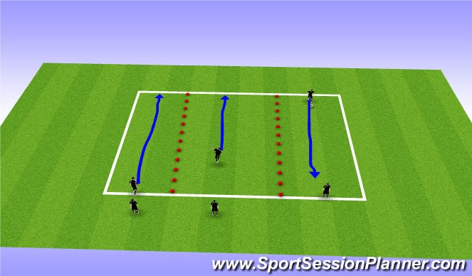
Dribbling across the grid and working on changing direction.
Moves to use: (allow each player 5-10 reps doing the move)
Pull back
Inside Chop (inside of foot)
Sweep (outside of foot)
end zone game 1v1 (15 mins)
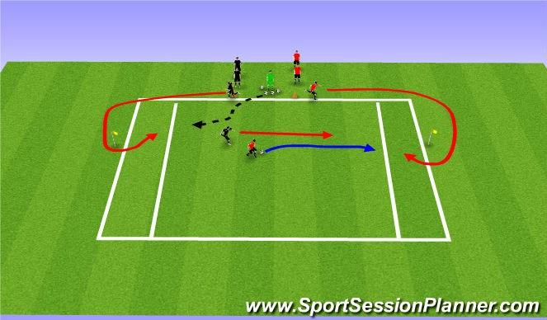
Players play 1v1 to get in the end zone and stop the ball
The ball must be stopped by the player in the endzone in order to get a point CP:
Ball Control
Dont Just kick
Head up
Change directions to beat attacker
2v1 endzone game (15 mins)
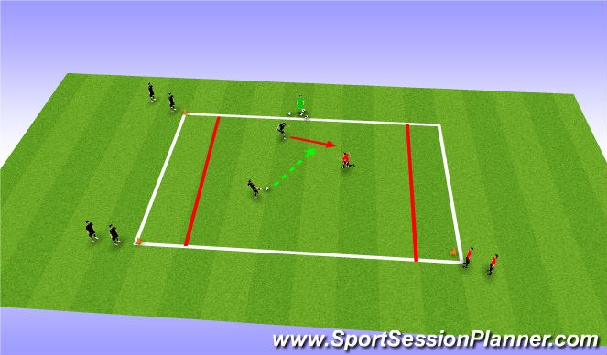
Players play 2v1 with 3 lines at the orange cones: attacking players stop ball in end zone
defender gets a point if they stop the ball in their endzone make players control the ball and look to pass when defender commits

2v2 endzone (20 mins)
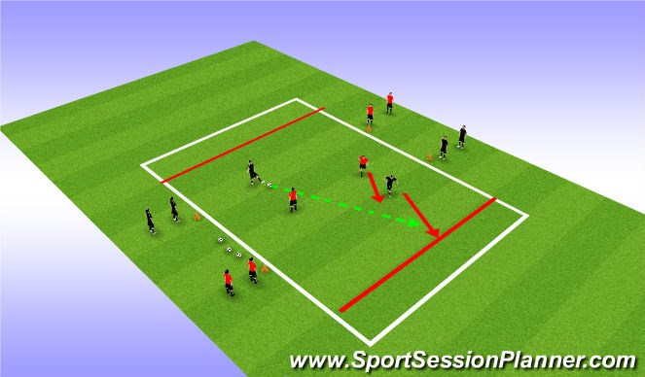
2v2 endzone game
each team can score in the endzone CP:
play passes that lead your teammate to desired area change point of attack.

